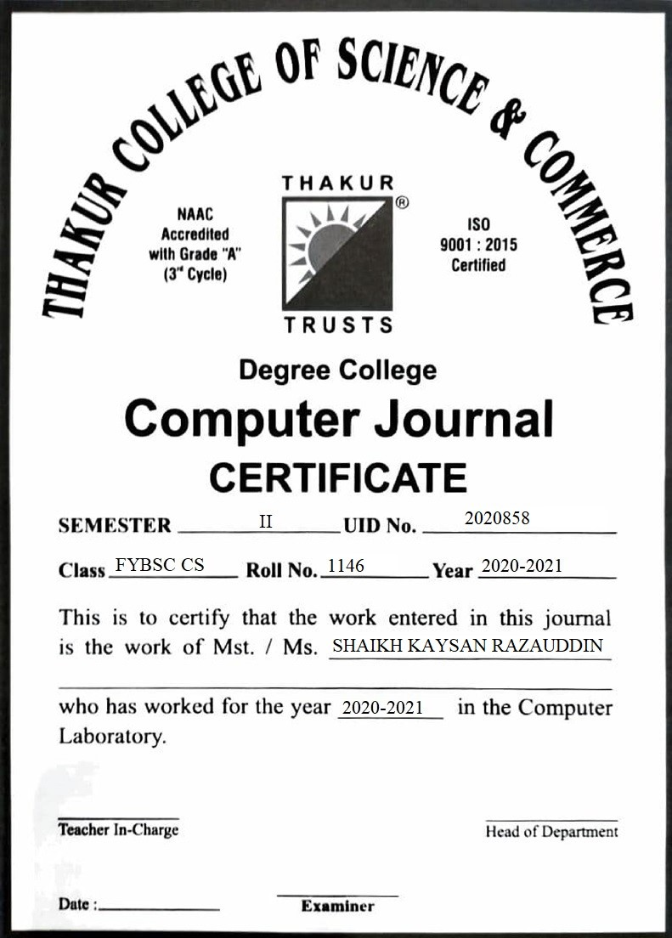

|  |  |  |  |
| --- | --- | --- | --- |
| **Sr. No.** | **Title** | **Page. No.** | **Date** |
| 1. | Programs to understand the basic data type and Input/output | 3 | 10/02/2021 |
| 2. | Programs on operations and expressions | 7 | 17/02/2021 |
| 3. | Programs on decision making and Branching | 12 | 24/02/2021 |
| 4. | Programs to demonstrate Loops | 18 | 03/03/2021 |
| 5. | Programs on Arrays | 25 | 17/03/2021 |
| 6. | Programs on Strings | 35 | 24/03/2021 |
| 7. | Programs on User defined Functions | 41 | 31/03/2021 |
| 8. | Programs on Pointers | 47 | 07/04/2021 |
| 9. | Program on Structures | 53 | 22/04/2021 |

**INDEX**

**Practical No: 01**

**Aim:** Programs to understand the basic data type and Input/Output.

**Program1: To print hello world.**

**Source code:**

#include <stdio.h>  
int main() {  
printf("Hello, World!");  
return 0;  
}

**Output:**

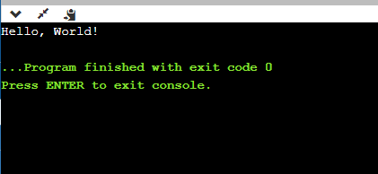

**Program2: Area of rectangle.**

**Source code:**

#include<stdio.h>  
int main()  
{  
int length, breadth, area;  
clrscr();  
printf(" Enter the Length of a Rectangle : ");  
scanf("%d",&length);  
printf("\n Enter the Breadth of a Rectangle : ");  
scanf("%d",&breadth);  
area = length * breadth;  
printf("\n Area of Rectangle is : %d",area);  
return 0;  
}

**Output:**

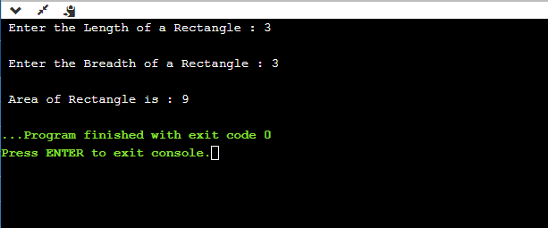

**Program3: Volume of sphere.**

**Source Code:**

#include<stdio.h>  
int main()  
{  
int r;  
float volume_sphere;  
printf("Enter Radius : ");  
scanf("%d",&r);  
volume_sphere = (4/3.0)*3.14*r*r*r;  
printf("\nVolume of Sphere = %f",volume_sphere);  
return 0;  
}

**Output:**

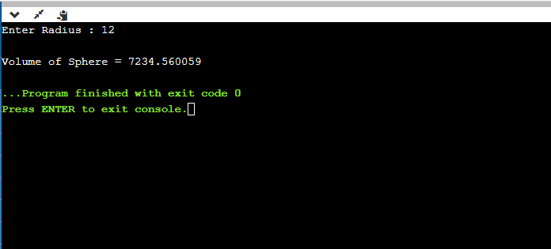

**Assignment Question: Write a program to find average of three numbers.**

**Source Code:**

#include<stdio.h>

int main()

{

int a,b,c,sum,avg;

printf("Enter three numbers: ");

scanf("%d%d%d",&a,&b,&c);

sum=a+b+c;

avg=sum/2;

printf("\nThe average of the three numbers is %d",avg);

return 0;}

**Output:**

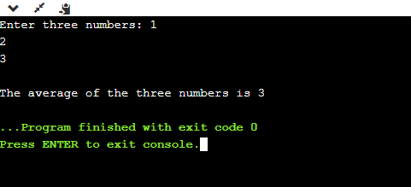

**Practical No: 02**

**Aim:** Programs on Operation and Expressions.

**Program 1:**

**Source Code:**

#include <stdio.h>  
//#include <conio.h>  
int main()  
{  
int a,b,c,d;  
a=10, b=10;  
printf("\n a=%d b=%d", a,b);  
c=++a-b;  
d=b+++a;  
printf("\n a=%d, b=%d, c=%d, d=%d",a,b,c,d);  
c=a%b;  
d=a/b;  
printf("\n a mod b: %d",c);  
printf("\n a divided by b: %d",d);  
return 0;  
//getch();  
}

**Output:**

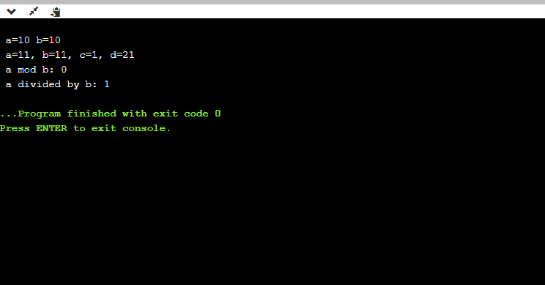

**Program 2:**

**Source Code:**

#include <stdio.h>  
//#include <conio.h>  
int main()  
{  
// your code goes here  
float a,b,c,x,y,z;  
a=12, b=9, c=3;  
printf("a=%f, b=%f, c=%f", a,b,c);  
x=a-b;  
y=a-b*2;  
z=a+b+c;  
printf("\n x=%f, y=%f, z=%f", x,y,z);  
return 0;  
//getch();  
}

**Output:**

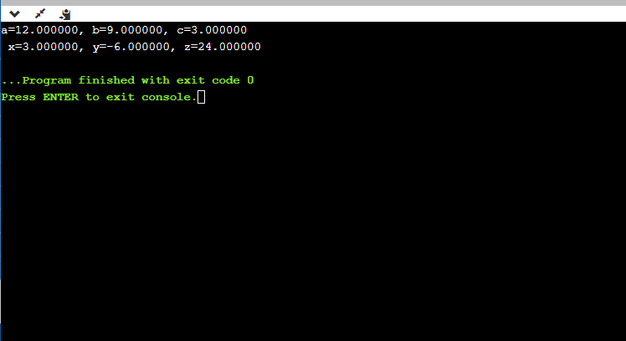

**Assignment Question: Write a program to demonstrate relational operator using float data type.**

**Source Code:**

// C program to demonstrate working of relational operators

#include <stdio.h>

int main()

{

int a = 24, b = 26;

// greater than example

if (a > b)

printf("a is greater than b\n");

else

printf("a is less than or equal to b\n");

// greater than equal to

if (a >= b)

printf("a is greater than or equal to b\n");

else

printf("a is lesser than b\n");

// less than example

if (a < b)

printf("a is less than b\n");

else

printf("a is greater than or equal to b\n");

// lesser than equal to

if (a <= b)

printf("a is lesser than or equal to b\n");

else

printf("a is greater than b\n");

// equal to

if (a == b)

printf("a is equal to b\n");

else

printf("a and b are not equal\n");

// not equal to

if (a != b)

printf("a is not equal to b\n");

else

printf("a is equal b\n");

return 0;

}

**Output:**

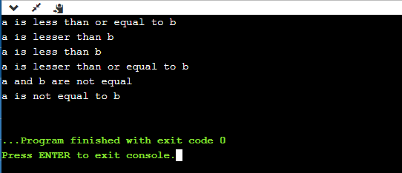

**Practical No: 03**

**Aim:** Programs on decision making and Branching.

**Program1: To check whether a number is even or odd.**

**Source Code:**

#include <stdio.h>  
int main() {  
int num;  
printf("Enter an integer: ");  
scanf("%d", &num);  
if(num % 2 == 0)  
printf("%d is even.", num);  
else  
printf("%d is odd.", num);  
return 0;  
}

**Output:**

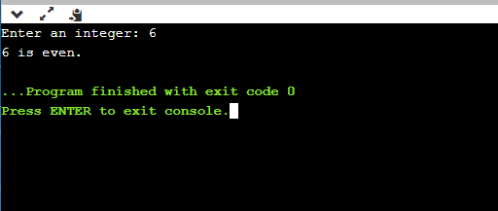

**Program2: To check whether a year is leap year or not.**

**Source Code:**

#include <stdio.h>  
int main() {  
int year;  
//year = 2016;  
printf("\nEnter a year:");  
scanf("\n%d",&year);  
if (year % 4 == 0)  
printf("\n%d is a leap year", year);  
else  
printf("\n%d is not a leap year", year);  
return 0;  
}

**Output:**

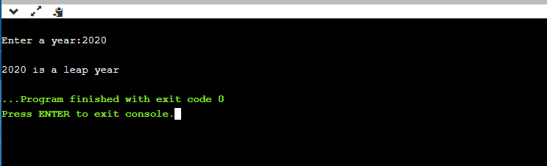

**Program3: To check largest of three numbers using nested if.**

**Source Code:**

#include <stdio.h>  
int main() {  
// Write C code here  
int a, b, c;  
printf("Enter three numbers: ");  
scanf("%d %d %d", &a, &b, &c);  
if (a >= b) {  
if (a >= c)  
printf("%d is the largest number.", a);  
else  
printf("%d is the largest number.", c);  
}  
else {  
if (b >= c)  
printf("%d is the largest number.", b);  
else  
printf("%d is the largest number.", c);  
}  
return 0;  
}

**Output:**

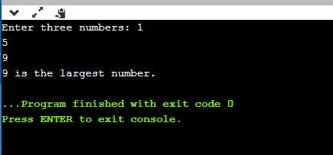

**Program 4: To add, sub, mul, div using switch case.**

**Source Code:**

#include <stdio.h>

int main() {

// Write C code here

int a,b,op;

printf(" 1.Addition\n 2.Subtraction\n 3.Multiplication\n 4.Division\n");

printf("Enter the values of a & b: ");

scanf("%d %d",&a,&b);

printf("Enter your Choice : ");

scanf("%d",&op);

switch(op)

{

case 1 :

printf("Sum is : %d",a+b);

break;

case 2 :

printf("Difference of %d and %d is : %d",a,b,a-b);

break;

case 3 :

printf("Multiplication of %d and %d is : %d",a,b,a*b);

break;

case 4 :

printf("Division of Two Numbers is :%d ",a/b);

break;

default :

printf(" Enter Your Correct Choice.");

break;

}

return 0;

}

**Output:**

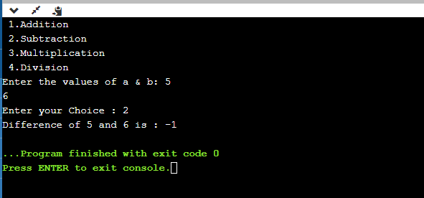

**Assignment Question: To Check whether alphabets is a vowel or not.**

**Source Code:**

#include <stdio.h>

int main()

{

char ch;

printf("Enter any character: ");

scanf("%c", &ch);

if(ch=='a' || ch=='e' || ch=='i' || ch=='o' || ch=='u' ||

ch=='A' || ch=='E' || ch=='I' || ch=='O' || ch=='U')

{

printf("'%c' is Vowel.", ch);

}

else if((ch >= 'a' && ch <= 'z') || (ch >= 'A' && ch <= 'Z'))

{

printf("'%c' is Consonant.", ch);

}

else

{

printf("'%c' is not an alphabet.", ch);

}

return 0;

}

**Output:**

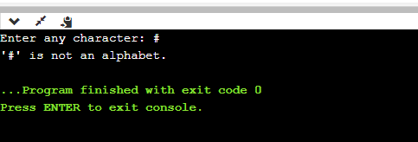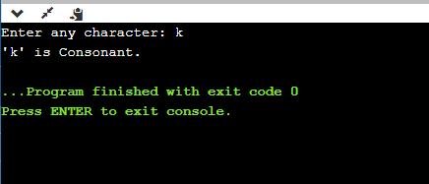

**Practical No: 04**

**Aim:** Programs to demonstrate Loops**.**

**Program1: To display the first 10 natural numbers using for loop.**

**Source Code:**

#include <stdio.h>

//#include<conio.h>

int main()

{

int i;

printf("The first 10 natural numbers are:\n");

for(i=0;i<=10;i++)

{

printf("\n %d ",i);

}

//getch();

return 0;

}

**Output:**

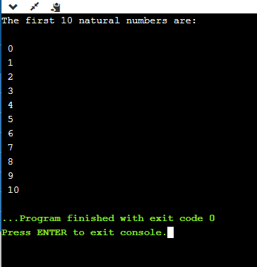

**Program2: To print all even numbers from 1 to 100 using while loop.**

**Source Code:**

#include <stdio.h>

//#include<conio.h>

int main()

{

int i=1,r;

printf("The even numbers between 1 to 100 are: \n");

while(i<=100)

{

r=i%2;

if(r==0)

{

printf("%d ",i);

}

i++;

}

return 0;

}

**Output:**

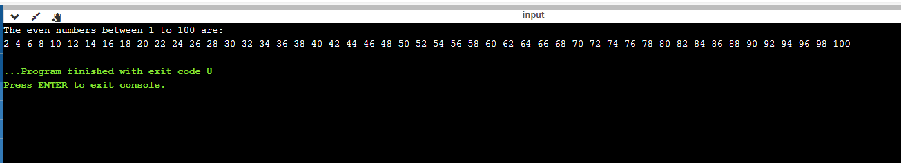

**Program3: To print the sum of all even numbers from 1 to n using Do while loop.**

**Source Code:**

#include <stdio.h>  
int main() {  
// Write C code here  
int i,n,r,s;  
printf("\nEnter value of n:");  
scanf("%d",&n);  
i=1,s=0;  
do  
{  
r=i%2;  
if(r==0)  
{  
s=s+i;  
}  
++i;  
}  
while(i<=n);  
printf("\nThe sum of all even numbers between 1 to %d is:%d",n,s);  
return 0;  
}

**Output:**

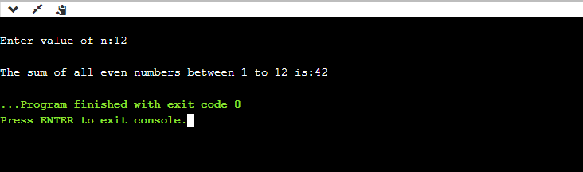

**Program4: Fibonacci series of first 20 terms.**

**Source Code:**

#include <stdio.h>  
int main() {  
int a,b,i,f;  
printf("\nFibonacci series:\n");  
a=1;  
b=0;  
printf("\n%d",b);  
for(i=3;i<=20;i++)  
{  
f=a+b;  
a=b;  
b=f;  
printf("\n%d",f);  
}  
return 0;  
}

**Output:**

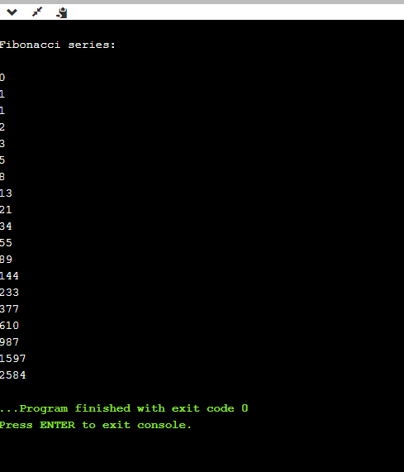

**Program5: To obtain the following output.**

*  
**  
***  
****  
**Source Code:**

#include <stdio.h>

int main()

{

int i,j;

for(i=1;i<=5;i++)

{

for(j=1;j<=i;j++)

printf("*");

printf("\n");

}

return 0;

}

**Output:**

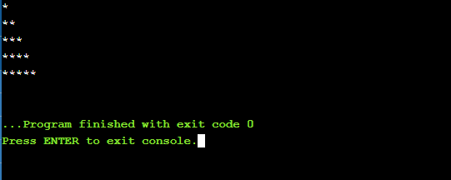

**Assignment Question: To Print numbers between 1 to n (from user) which is divisible by 8.**

**Source Code:**

#include <stdio.h>

int main()

{

int i,a, sum=0;

printf("Print the numbers till:");

scanf("%d", &a);

printf("Number = %d",a);

printf("Numbers between 1 to 200, divisible by 8 : \n");

for(i=1;i<a;i++)

{

if(i%8==0)

{

printf("% 5d",i);

sum+=i;

}

}

printf("\n\nThe sum : %d \n",sum);

}

**Output:**

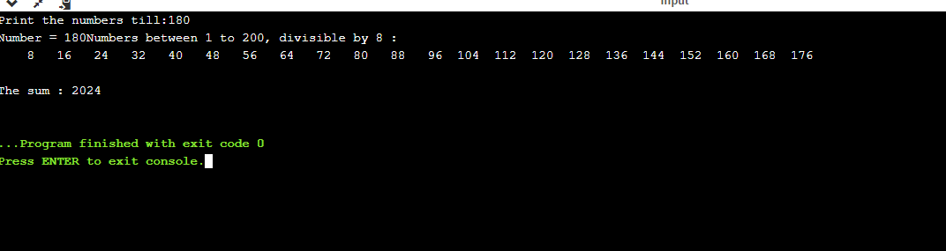

**Practical No: 05**

**Aim:** Programs on Arrays.

**Program 1: Program to print elements of array in reverse order.**

**Source Code:**

#include<stdio.h>

int main()

{

int i, arr1[5];

for(i=0;i<5;i++)

{

printf("Enter Element[%d]:",i);

scanf("%d",&arr1[1]);

}

printf("Array elements in reverse order are:\n");

for(i=4;i>=0;i--)

{

printf("Element[%d]: %d\n",i,arr1[i]);

}

}

**Output:**

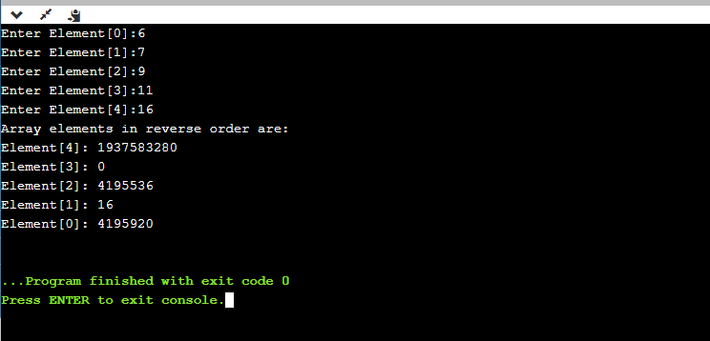

**Program 2: To find largest element in an array.**

**Source Code:**

#include<stdio.h>

int main()

{

int n;

int arr[100];

printf("Enter the number of elements (1 to 100):");

scanf("%d",&n);

for(int i = 0; i<n;++i)

{

printf("Enter number%d:",i+1);

scanf("%d", &arr[i]);

}

// storing the largest number to arr[0]

for(int i=1; i<n;++i){

if(arr[0]<arr[i]){

arr[0]=arr[i];

}

}

printf("Largest element= %d",arr[0]);

return 0;

}

**Output:**

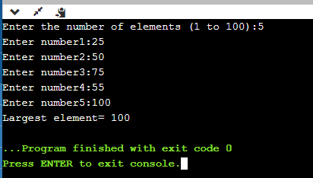

**Program 3: To read and print a RxC Matrix.**

**Source Code:**

#include <stdio.h>

int main()

{

int matrix[10][10];

int i,j,r,c;

printf("Enter number of Rows :");

scanf("%d",&r);

printf("Enter number of Cols :");

scanf("%d",&c);

printf("\nEnter matrix elements :\n");

for(i=0;i< r;i++)

{

for(j=0;j< c;j++)

{

printf("Enter element [%d,%d] : ",i+1,j+1);

scanf("%d",&matrix[i][j]);

}

}

printf("\nMatrix is :\n");

for(i=0;i< r;i++)

{

for(j=0;j< c;j++)

{

printf("%d\t",matrix[i][j]);

}

printf("\n"); /*new line after row elements*/

}

return 0;

}

**Output:**

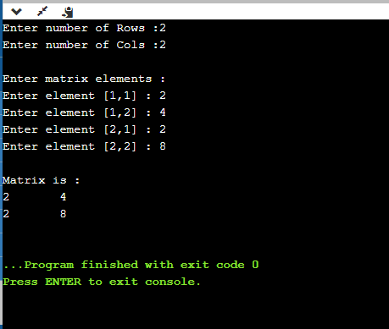

**Program 4: Matrix Multiplication.**

**Source Code:**

#include<stdio.h>

int main(){

int a[10][10],b[10][10],mul[10][10],r,c,i,j,k;

printf("enter the number of row=");

scanf("%d",&r);

printf("enter the number of column=");

scanf("%d",&c);

printf("enter the first matrix element=\n");

for(i=0;i<r;i++)

{

for(j=0;j<c;j++)

{

scanf("%d",&a[i][j]);

}

}

printf("enter the second matrix element=\n");

for(i=0;i<r;i++)

{

for(j=0;j<c;j++)

{

scanf("%d",&b[i][j]);

}

}

printf("multiply of the matrix=\n");

for(i=0;i<r;i++)

{

for(j=0;j<c;j++)

{

mul[i][j]=0;

for(k=0;k<c;k++)

{

mul[i][j]+=a[i][k]*b[k][j]; //a=a+b is also written as a+=b

}

}

}

//for printing result

for(i=0;i<r;i++)

{

for(j=0;j<c;j++)

{

printf("%d\t",mul[i][j]);

}

printf("\n");

}

return 0;

}

**Output:**

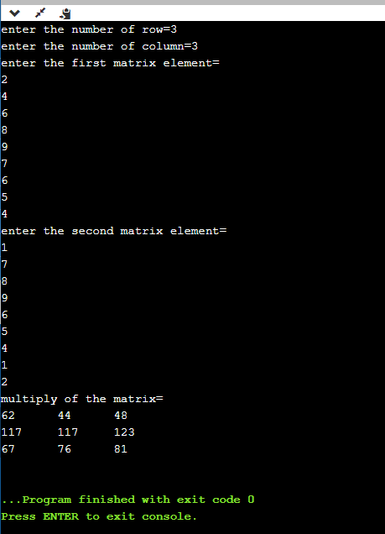

**Assignment Question: To print the sum of all elements in One dimensional array.**

**Source code:**

#include <stdio.h>

int main()

{

int a[100];

int i, n, sum=0;

printf("Input the number of elements to be stored in the array :");

scanf("%d",&n);

printf("Input %d elements in the array :\n",n);

for(i=0;i<n;i++)

{

printf("element - %d : ",i);

scanf("%d",&a[i]);

}

for(i=0; i<n; i++)

{

sum += a[i];

}

printf("Sum of all elements stored in the array is : %d\n\n", sum);

}

**Output:**

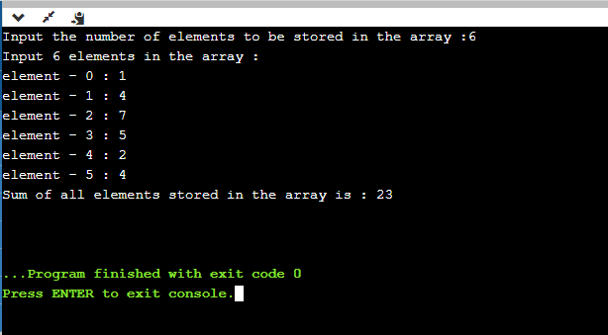

**Practical No: 06**

**Aim:** Programs on Strings.

**Program1: To read string of words using scanf().**

**Source Code:**

#include <stdio.h>

#include<string.h>

int main() {

// Write C code here

char w1[20],w2[20],w3[20],w4[20];

printf("Enter text of words:");

scanf("\n%s %s %s %s",&w1,&w2,&w3,&w4);

printf("\nWord 1:%s",w1);

printf("\nWord 2:%s",w2);

printf("\nWord 3:%s",w3);

printf("\nWord 4:%s",w4);

return 0;

}

**Output:**

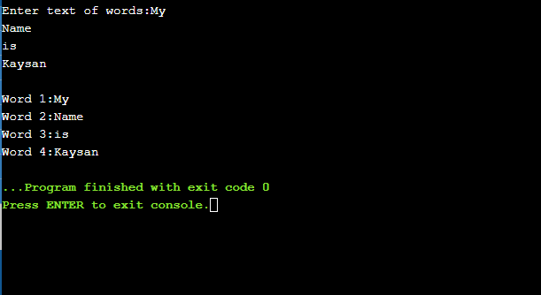

**Program 2: Matrix Multiplication.**

**Source Code:**

#include <stdio.h>

int main()

{

char ch[30];

printf("Enter the string: ");

gets(ch);

printf("you entered string here\n");

puts(ch);

return 0;

}

**Output:**

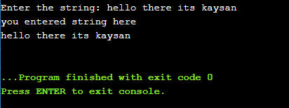

**Program 3: Program to copy one string into another.**

**Source Code:**

#include <stdio.h>

#include <string.h>

int main()

{

char text1[100], text2[100];

/* Input original string from user */

printf("Enter any string: ");

gets(text1);

/* Copy text1 to text2 using strcpy() */

strcpy(text2, text1);

printf("First string = %s\n", text1);

printf("Second string = %s\n", text2);

return 0;

}

**Output:**

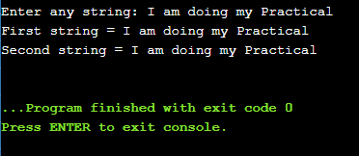

**Program 4: To use strupr() and strlwr() function.**

**Source Code:**

#include<stdio.h>

#include<conio.h>

#include <string.h>

clrscr();

int main()

{

char str[] = "COMPUTER science”

printf("Given string is: %s\n", str);

printf("\nstring after converting to the uppercase is: %s", strupr(str));

getch();

}

**Output:**

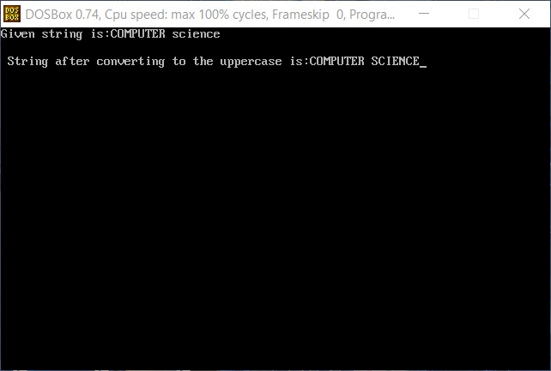

**Program 5: To use strlen() function.**

**Source Code:**

#include <stdio.h>

#include <string.h>

int main()

{

char text[100];

int length;

printf("Enter any string: ");

gets(text);

length = strlen(text);

printf("Length of '%s' = %d", text, length);

return 0;

}

**Output:**

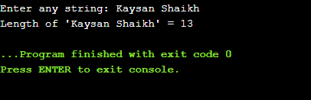

**Assignment Question: Program to use strcat() function.**

**Source code:**

#include <stdio.h>

#include <string.h>

int main( )

{

char source[ ] = "strcat()" ;

char target[ ]= " Program in C " ;

printf ( "\nSource string = %s", source ) ;

printf ( "\nTarget string = %s", target ) ;

strcat ( target, source ) ;

printf ( "\nTarget string after strcat( ) = %s \n", target ) ;

}

**Output:**

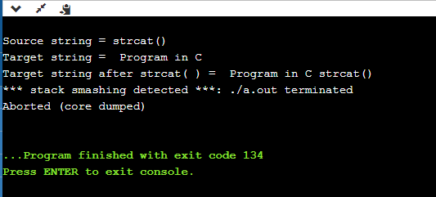

**Practical No: 07**

**Aim:** Programs on User-defined Functions.

**Program 1: To print square of a number.**

**Source code:**

#include <stdio.h>

float square(float num)

{

return (num * num);

}

int main()

{

int num;

float n;

printf("\n\n Function : find square of any number :\n");

printf("Input any number for square : ");

scanf("%d", &num);

n = square(num);

printf("The square of %d is : %.2f\n", num, n);

return 0;

}

**Output:**

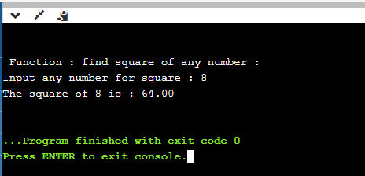

**Program 2: To print digit of entered number.**

**Source code:**

#include<stdio.h>

#include<conio.h>

int get_no(void);

void main() {

int m;

m=get_no();

printf(“\nEntered num is=%d ”,m);

getch();

}

int get_no(void)

{

int num;

printf(“Enter num:”);

scanf(“%d”,&num);

return(num);

}

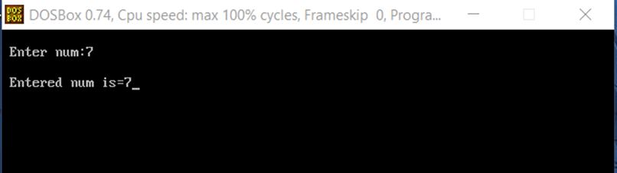**Output:**

**Program 3: To find average of three numbers.**

**Source code:**

#include<stdio.h>

#include<conio.h>

float   avg(int a,int b,int c);

void main()

{

    int a,b,c;

   float average;

printf("Enter the first integer number: ");

    scanf("%d",&a);

    printf("Enter the second integer number: ");

    scanf("%d",&b);

    printf("Enter the third number: “);

    scanf("%d",&c);

average=avg(a,b,c);

printf(“the average of entered three numbers is:%f”,average);

     getch();

float avg(int a,int b,int c)

{

    int sum=a+b+c;

    return (float)sum/3;

}

**Output:**

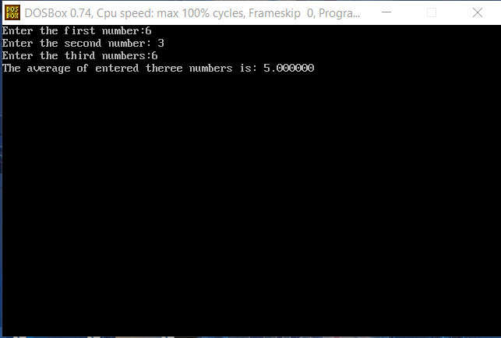

**Program 4: Factorial of a number using recursion.**

**Source code:**

#include <stdio.h>

int fact(int);

int main()

{

int num;

printf("Enter a number: ");

scanf("%d", &num);

printf("\nFactorial of %d is %d.\n", num, fact(num));

return 0;

}

int fact(int num)

{

if(num)

return(num * fact(num - 1));

else

return 1;

}

**Output:**

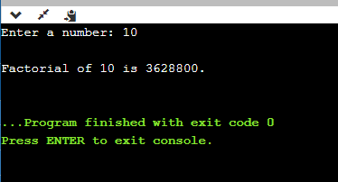

**Assignment Question: To find the cube root of a number using function.**

**Source code:**

#include <stdio.h>

double cubeRoot(double n) {

double i, precision = 0.000001;

for(i = 1; (i*i*i) <= n; ++i);

for(--i; (i*i*i) < n; i += precision);

return i;

}

int main() {

int n = 16;

printf("Cube root of %d = %lf", n, cubeRoot(n));

return 0;

}

**Output:**

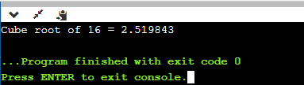

**Practical No: 08**

**Aim:** Programs on Pointers.

**Program1: To show the basic declaration of pointer.**

**Source Code:**

#include <stdio.h>

int main()

{

int m=10, n, o;

int *z=&m;

printf("\n\n z stores the address of m = %p\n", z); //& //*

printf("\n *z stores the value of m= %i\n", *z);

printf("\n &m is the address of m= %p\n", &m);

printf("\n &n stores the address of n= %p\n", &n);

printf("\n &o stores the address of o= %p\n", &o);

printf("\n &z stores the address of z= %p\n\n", &z);

return 0;

}

**Output:**

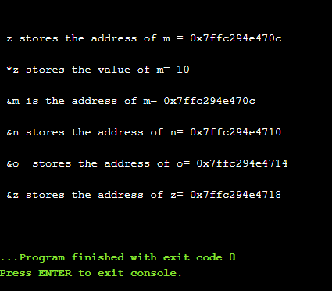

**Program 2: To find difference of two numbers using pointers.**

**Source code:**

#include <stdio.h>

int main()

{

int fno, sno, *ptr, *qtr, sub;

printf(" Input the first number : ");

scanf("%d", &fno);

printf(" Input the second number : ");

scanf("%d", &sno);

ptr = &fno;

qtr = &sno;

sub = *ptr - *qtr;

printf(" The sub of the entered numbers is : %d\n\n",sub);

return 0;

}

**Output:**

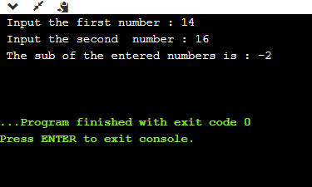

**Program 3: To swap elements using call by reference.**

**Source code:**

#include <stdio.h>

void swapNumbers(int *x,int *y);

int main()

{

int e1,e2;

printf("Enter thr 1st element : ");

scanf("%d",&e1);

printf("Enter the 2nd element : ");

scanf("%d",&e2);

swapNumbers(&e1,&e2);

printf("\n The value after swapping are :\n");

printf(" element 1 = %d\n element 2 = %d\n",e1,e2);

return 0;

}

void swapNumbers(int *x,int *y)

{

int tmp;

tmp=*y;

*y=*x;

*x=tmp;

return 0;

}

**Output:**

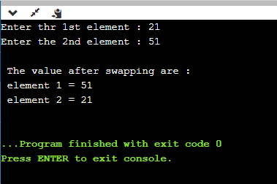

**Program 4: To print elements of arrays using pointers.**

**Source code:**

#include <stdio.h>

int main()

{

int arr1[25], i,n;

printf("Enter the number of elements to store in the array:");

scanf("%d",&n);

printf(" Input %d number of elements in the array :\n",n);

for(i=0;i<n;i++)//5

{

printf(" element - %d : ",i);

scanf("%d",arr1+i);

}

printf(" The elements you entered are : \n");

for(i=0;i<n;i++)

{

printf(" element - %d : %d \n",i,*(arr1+i));

}

return 0;

}

**Output:**

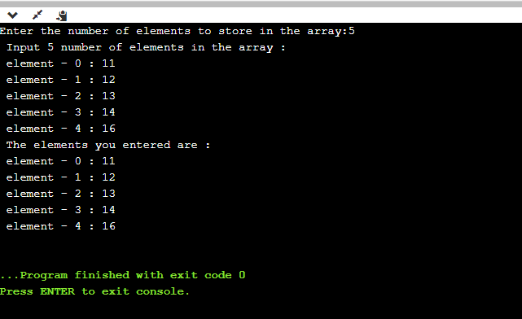

**Practical No: 09**

**Aim:** Program on Structures.

**Program1: Student Structure.**

**Source Code:**

#include <stdio.h>  
struct StudentData{  
char stu_name[50];  
int stu_id;  
int stu_age;  
};  
int main()  
{  
struct StudentData s; //s.sname,s.age,s.id  
printf("Enter the details:");  
scanf("%s %d %d",&s.stu_name,&s.stu_id,&s.stu_age);  
/* Displaying the values of struct members */  
printf("Student Name is: %s", s.stu_name);  
printf("\nStudent Id is: %d", s.stu_id);  
printf("\nStudent Age is: %d", s.stu_age);  
return 0;  
}

**Output:**

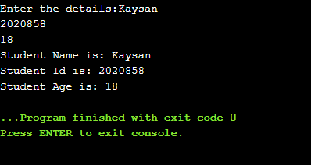

**Program 2: Employee comparison.**

**Source code:**

#include <stdio.h>

struct emp{

    int eno,salary;

};

int main() {

    // Write C codehere

    struct emp n,y; //n is for 1st employee & y is for second employee

    printf("\nEnter eno and salary:");

    scanf("%d %d",&n.eno,&n.salary);//for 1st employee

printf("\nEnter eno and salary:");

    scanf("%d %d",&y.eno,&y.salary);//for 2nd employee

if(n.eno==y.eno & n.salary==y.salary)

{

    printf("both are equal");

}

else

    printf("both are unequal");

    return 0;

}

**Output:**

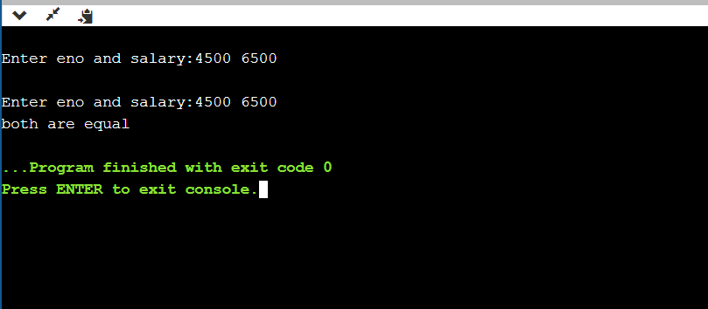

**Program 3: Fruit Structure.**

**Source code:**

#include &lt;stdio.h&gt;

#include &lt;string.h&gt;

struct fruit

{

char name[50];

int qty;

float price;

};

int main()

{

int i;

struct fruit f1[5]; //iint arr[5]

printf(“enter name,qty and price of fruits:”);

for(i=0;i<2;i++)

{

Scanf(“%s %d %f1[i],&f1[i].name,&amp;f1[i].qty,&f1[i].price);

}

for(i=0;i<2;i++)

{

printf(“\n Name=%s, Qty=%d,price=%f”,f1[i].name,f1[i].qty,f1[i].price);

}

return 0;

}

**Output:**

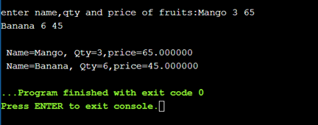

**Assignment Question: Create a structure for books.**

**Source Code:**

#include<stdio.h>

#include<string.h>

#define SIZE 20

struct bookdetail

{

char name[20];

char author[20];

int pages;

float price;

};

void output(struct bookdetail v[],int n);

void main()

{

struct bookdetail b[SIZE];

int num,i;

printf("Enter the Numbers of Books:");

scanf("%d",&num);

printf("\n");

for(i=0;i<num;i++)

{

printf("\t=:Book %d Detail:=\n",i+1);

printf("\nEnter the Book Name:\n");

scanf("%s",b[i].name);

printf("Enter the Author of Book:\n");

scanf("%s",b[i].author);

printf("Enter the Pages of Book:\n");

scanf("%d",&b[i].pages);

printf("Enter the Price of Book:\n");

scanf("%f",&b[i].price);

}

output(b,num);

}

void output(struct bookdetail v[],int n)

{

int i,t=1;

for(i=0;i<n;i++,t++)

{

printf("\n");

printf("Book No.%d\n",t);

printf("\t\tBook %d Name is=%s \n",t,v[i].name);

printf("\t\tBook %d Author is=%s \n",t,v[i].author);

printf("\t\tBook %d Pages is=%d \n",t,v[i].pages);

printf("\t\tBook %d Price is=%f \n",t,v[i].price);

printf("\n");

}

}

**Output:**

